**Manual Process to Create, Edit, or Delete Users**

**Create User**

1. Log into Pearson Access (PA)
2. On the left select Users
3. Click Create User

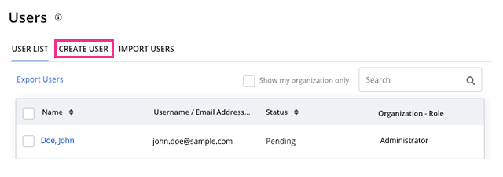

1. Enter required user details and click **Select Role** to select the user's role. *Roles vary by project*

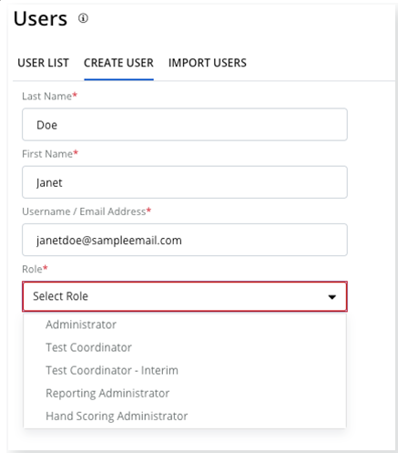

1. Click Create User

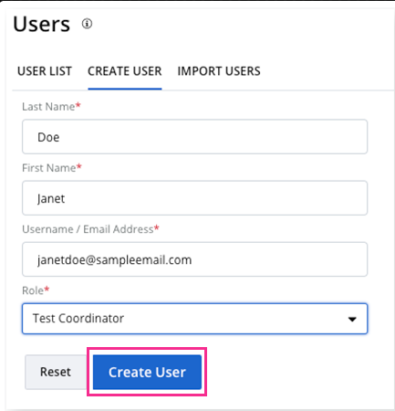

A success message appears.

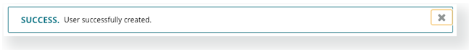

**Edit User Details**

You **cannot** edit a user's **organization** or **role**. To update those details, you must delete, and then, recreate the user.

1. Log into Pearson Access (PA)
2. On the left select Users
3. Scroll to find the user or search for his or her name and click it.

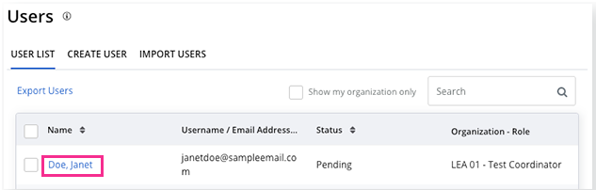

1. Click **Edit**.  
   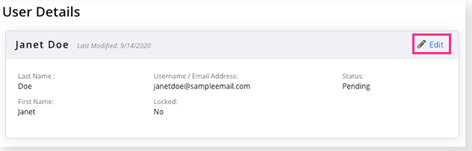
2. Update user details and click **Save**.

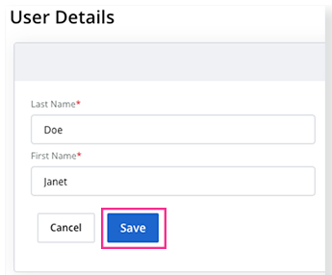

**Delete User**

1. Log into Pearson Access (PA)
2. On the left select User
3. Scroll to find the user or search for his or her name, and select it.
4. Click **Delete**. You can also resend an invite to the user

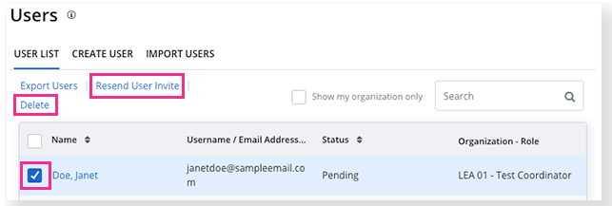

1. Click Confirm.

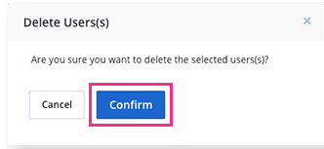

A success message appears.



**Import Process to Create, Edit, or Delete Users**

1. Log into Pearson Access (PA)
2. On the left select Users
3. Click on Import Users

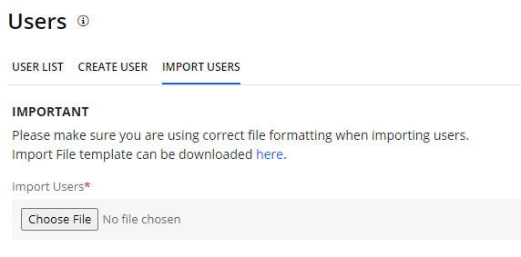

1. Click on Import File Template can be downloaded here

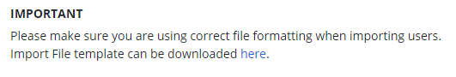

1. Complete required fields.
   1. Below are the requirements for completing the User Import Template.

|  |  |  |  |  |  |
| --- | --- | --- | --- | --- | --- |
| **Column** | **Field Name (CSV Header)** | **Required**  **Y/N** | **Field Length** | **Field Definitions** | **Valid Values** |
| A | Update Indicator (updateIndicator) | Y | 1 | Identifies rows to be added or updated. If this value is not provided, the record will fail to load. | I = Insert U = Update D = Delete |
| B | Customer Code | Y | 255 | Pearson created unique ID to identify project. | BIE  Must be in uppercase |
| C | Organization Code | Y | 50 | The Organization of the school the user needs to be assigned or removed. | Numeric 0-9  Alpha |
| D | First Name | Y | 255 | User First Name | Alpha  Space |
| E | Last Name | Y | 255 | User Last Name | Alpha  Space |
| F | Role | Y | 255 | Permission role assigned to the user for the organization. *If a user is associated to multiple organizations, a separate row for each organization is required. | Test Coordinator  Test Administrator Teacher  Reporting Administrator |
| G | Email | Y | 255 | School email assigned | Blank Before the @: A-Z, a-z, 0-9, ., _, %, +, `, ~, /, #, $, !, &, ', *, =, ?, ^, {, |, }, -  After the @ A-Z, a-z, 0-9. - After the last period (.), 2-4 in length A-Z, a-z |

1. Import Users by selecting Choose File

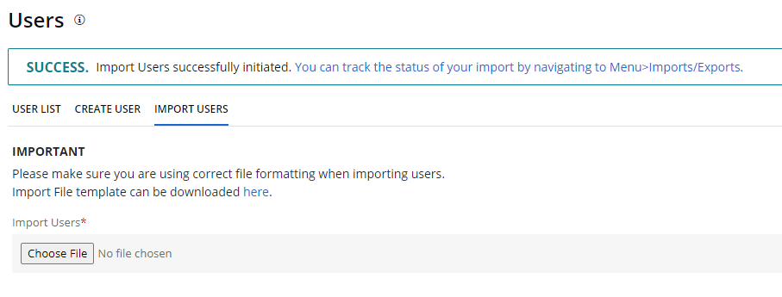

1. Verify Import on Import/Export Screen

